Welcome to our NEW Assigning Program!

**1st-Time Login**

1. Enter the system – www. <http://gymjas.com> and click on OHIO

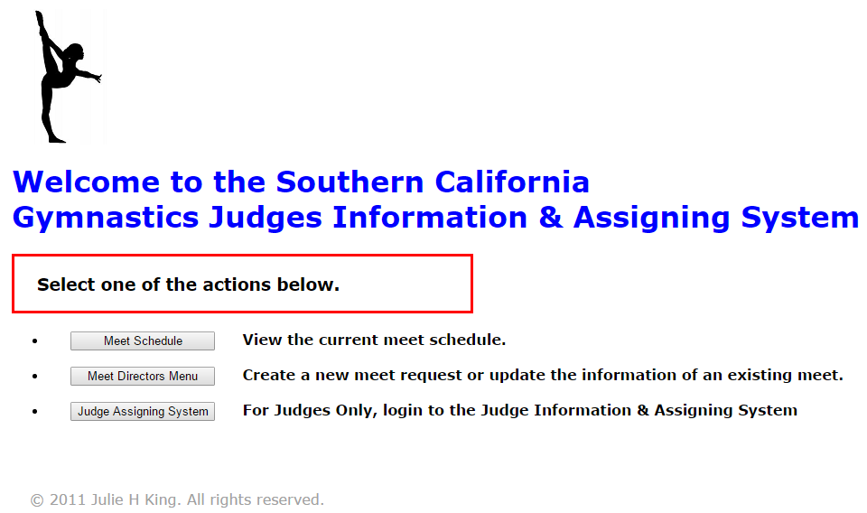

1. Click on the **JUDGE ASSIGNING SYSTEM** button



1. Click, **register here**

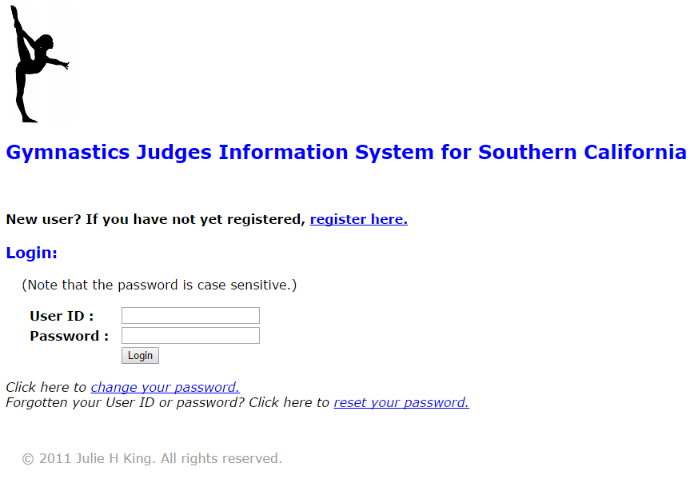

1. Fill in the following info:
   * **USAG#**
   * Create a **USER NAME**
   * And **PASSWORD** and **Confirm**
   * Click the **Register** button

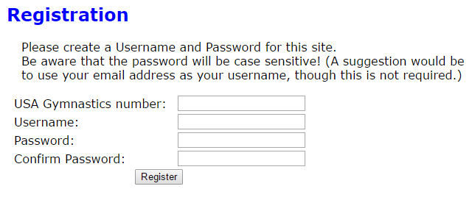

1. Now you are ready to **Login**



**Updating Your Information**

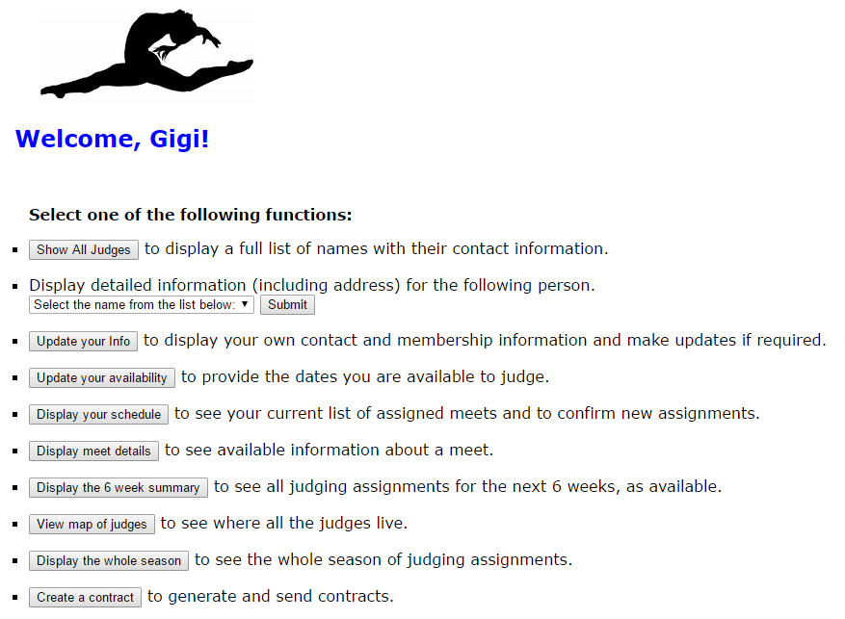

Judy Judge

1. On the **Welcome** page, click the **UPDATE YOUR INFO** button



* + Please update the pink fields only
  + **Name** - spelling, if wrong
  + Add **AAU #,** if applicable
  + **Affiliation** - Please list all affiliations
  + **Email address**, if wrong
  + **Cell #** (please list number where others may get a hold of you for carpooling)
  + **Home#** (please list number where others may get a hold of you for carpooling)
  + **Update address** – if you have given us a **PO Box**, please update with the physical address of where you will carpool from. This field is linked to the GEO map that helps our assigners, assign more efficiently by seeing who is in similar areas to carpool.
  + **Expiration Dates**: Once your Memberships are renewed, please update this dates here. These will be verified and only judges with current Memberships will be allowed to be assigned per USAG and NAWGJ rules.
  + Then, **click to SAVE UPDATES**

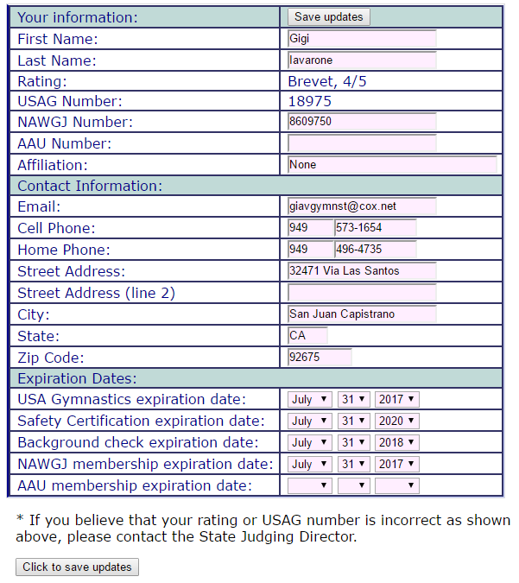

XXXXXX

* + If your rating has changed or is wrong, please email Lori at [ohiosjd@gmail.com](mailto:ohiosjd@gmail.com) and she will verify it by logging onto USAG or you can expedite the process by attaching your rating card to the email or forwarding the results letter.

**Entering your Availability**





1. On the **Welcome** page, click the **UPDATE YOUR AVAILABILITY** button

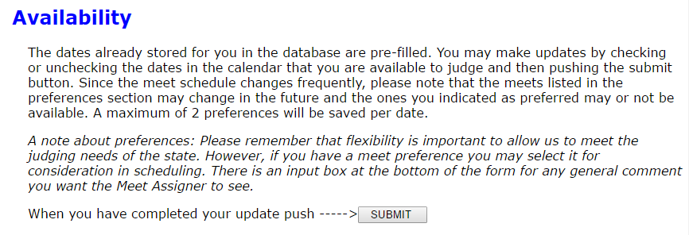

* + It is important in this system to mark yourself available on ANY dates you are willing to judge. There may not be a lot of meets in your area a certain weekend but there may be meets needing judges in other areas. Having yourself available will make the assigners job much EASIER!
  + Also, please recheck your availability every so often as schedules can change. You may miss opportunities to judge or neglect to become “unavailable” and find yourself already assigned.

1. On this page you will see the **monthly calendars** and the **list of meets with their start dates** in a box **underneath** or to the **side,** depending on your monitor size.

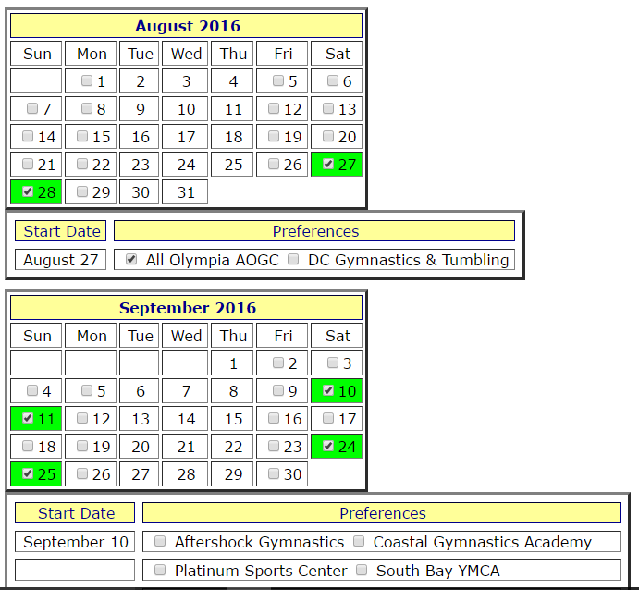

or

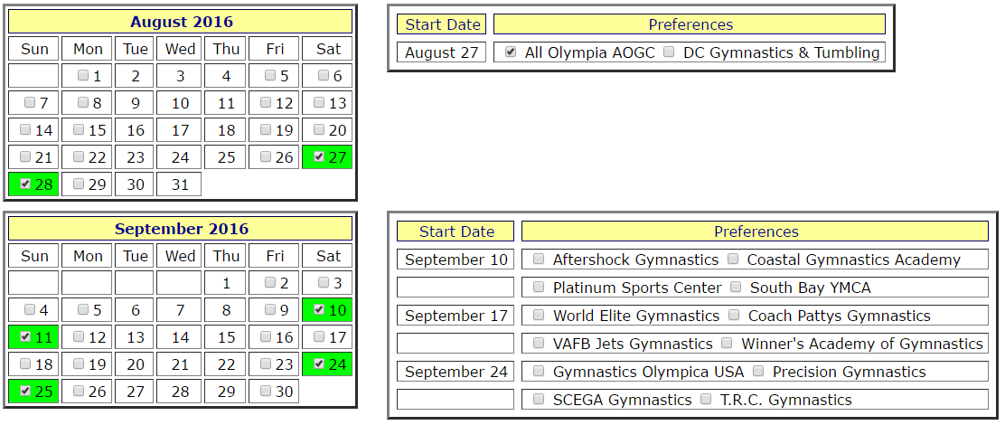

1. Start by clicking on the days you are available on each weekend that has competitions.
   * Click Saturday and Sunday if you can judge the whole weekend

* During the Optional Season, large competitions will start on Friday, so please give us your Friday availability in case 2-day meets get extended to 3-days. (some are already set-up for 3 days)
  + Click Saturday or Sunday (for that 1 day specifically)
  + If you want an **Either Day** choice, click on **BOTH** Saturday and Sunday and at the bottom of the form, in the “**COMMENTS” section** state that you only want to judge 1 day on each weekend.

1. In the **Preference Box**, click on the meets you prefer to Judge (this is just a guideline for the assigners and there is no guarantee you will be judging there) (Remember to show availability even if there is no meet in your area listed)
   * Max of **2 preferences per weekend** can be saved
2. After filling out your **AVAILABILITY**, make sure to put any “**COMMENTS**” you may have in the **box** at the bottom
   * **All comments** appear on every weekend for the assigner to see - try to make them **General** but if you have anything you need to convey, do it here and make sure to do it clearly and concisely. The field only holds 150 characters!

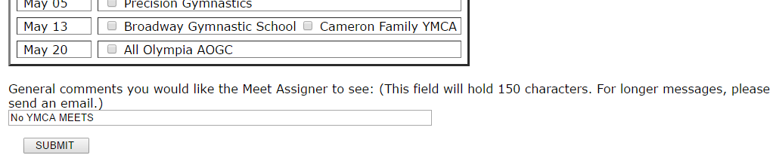

1. When you are finished, please click the **SUBMIT** button at the bottom or at the top of the form.
   * **Anytime you need to make adjustments, make sure to click submit**.

**Accepting Your Assignment**



cid:image001.png@01D1EBBF.292AB280

1. On the **Welcome** page, click the **DISPLAY YOUR SCHEDULE** button and the list of competitions you have been assigned to will show up.

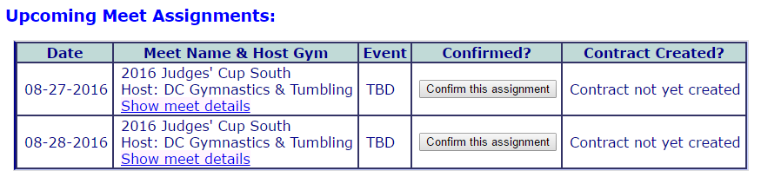

1. Please examine your list of meets and the days that you have been assigned, both Saturday and Sunday.
   * Click the **Show Meet Details** to see more information on the competition. Here you will see:
     + Host gym and address
     + Meet Director information
     + Meet location
     + Others assigned to the competition
     + Uniform info
     + Meet type: USAG, AAU, etc.
     + Meet format
     + Name of Assigner and any comments the assigner needs you to see

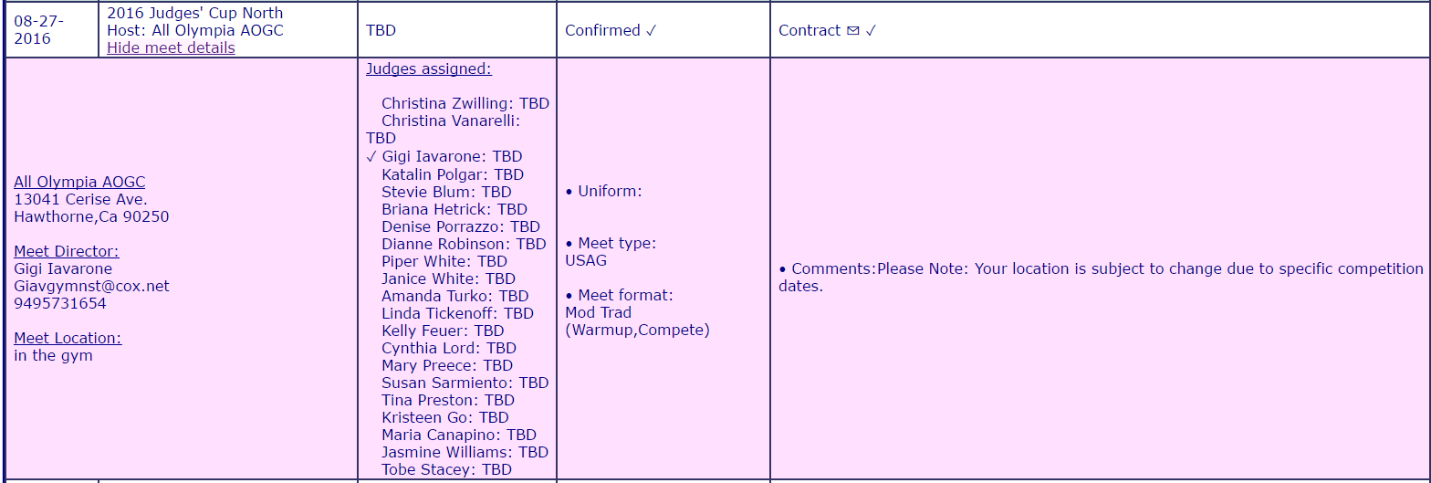

1. Click the **CONFIRM THIS ASSIGNMENT** button, to acknowledge the assignments and accept them.
   * Pushing the **Confirm This Assignment** button, will confirm both days of a weekend automatically. If your availability has changed, at this time, and you can only do one of the days, still click the **Confirm** button, however, you must notify the Assigner immediately. (The Assigner for the Meets can be found in the Comments box in the **SHOW MEET DETAILS** section)

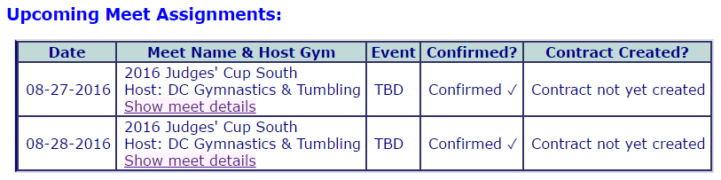

* + Once you have acknowledged your list of competitions by clicking the **Confirm This Assignment** button for each competition, it is now time to generate your contracts.

**Generating a Contract**





1. **STOP!** In order to contract your competitions, all your Membership Information needs to be RENEWED and the information needs to be updated under the **UPDATE YOUR INFORMATION** button on the Home Page. This will be verified.
   * Please update prior to contracting or your contracts will be NULL and VOID.
   * Did you know your NAWGJ number no longer starts with P-1? The New numbers can be found on your payment receipt emails.
   * Please change it if you had the P-1, P-2 number listed.

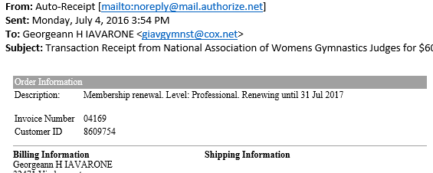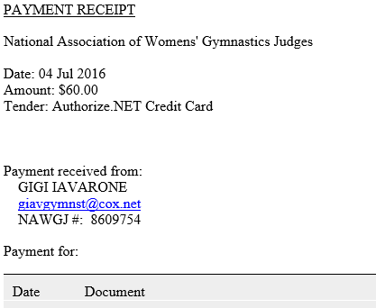

1. On the **Welcome** page, click the **CREATE A CONTRACT** button and the list of competitions you have acknowledged to will appear on the screen.

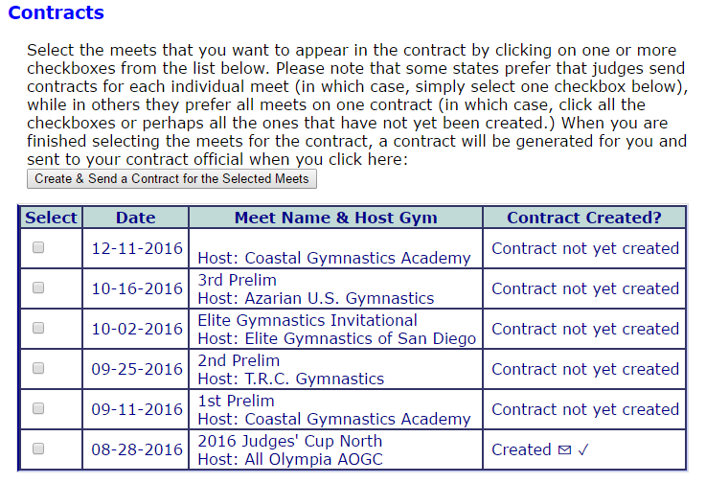

1. Click the checkboxes on the right, for the meet(s) that you have no issues with and Click on the **CREATE & SEND A CONTRACT FOR THE SELECTED MEETS** button. (**Careful!** This button is above the grid, not below. The return to main screen is below)
   * For the competitions you have issues with, wait for the **Assigner** to let you know when the system has been updated with the correct information. i.e. removing you from one day or switching your day, if possible.

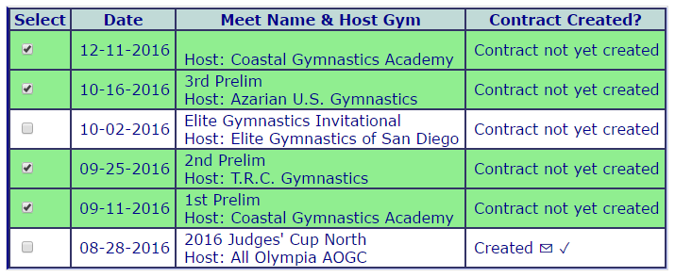

1. Once the issue(s) have been fixed, go in and **Create a Contract** for all remaining meets.
2. During the course of the season, if you are added to a competition, you must complete the **Create a Contract** portion for the added meets.
3. Created 🖂 ✓ means your contracted has been submitted. Once submitted if you have any unforeseen issues with one of your meets, please contact the Assigner for the competition.

**During the season, meet information will be going out as usual and you will have your assignments no later than 7 days in advance! Contracts may be received before meet information is available- especially for large invitationals or state meets.**

**Please let your assigner or myself know if you are having difficulties with any of the process listed in these instructions. This is a NEW process for us all!**

**NAWGJ OHIO ASSIGNERS**

**Lori Powers-Basinger, SJD ohiosjd@gmail.com**

**Christina Andres, Central candes1204@gmail.com**

**Kathleen Edwards, Southwest kathleencedwards @gmail.com**

**Barb Giulivo, North bgiulivo@aol.com**

**Tina Snyder, Northwest msnyder9@columbus.rr.com**

**Barb Wright, Northeast ohneassigner@gmail.com**